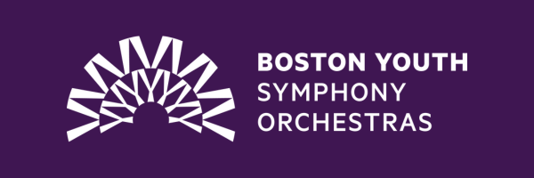

To purchase tickets to attend one of our BYSO concerts held this season at the Boston Children’s Museum, all you need to do is purchase an admission ticket to the Museum. Tickets can be purchased in advance or on the day of. This ticket will allow you access to the museum per normal, but also the chance to see our talented musicians perform!

To purchase a ticket now, visit [Reserve Tickets - Boston Children's Museum (bostonchildrensmuseum.org)](https://bostonchildrensmuseum.org/ticketing/).

We hope to see you there!